**Project Report**



**Winter of Code 4.0**

# 

# Harsh Mishra

# IIT(ISM) Dhanbad

**Description-**

**Machine learning (ML) is a type of artificial intelligence (AI) that allows software applications to become more accurate at predicting outcomes without being explicitly programmed to do so. Machine learning algorithms use historical data as input to predict new output values.**

**In the project I have implemented several basic ML algorithms using only a few libraries namely – Pandas, Numpy, Matplotlib etc.**

# Project Implementation-

**Linear Regression: -**

Linear regression is an algorithm using which we find a linear relation between the given variables and the attached label. It is the most basic form of machine learning algorithm.

# 

# 

An example of linear regression.

In the model that I had implemented and using the data provided I was able to get an R2 score of **[0.99999986].**

**Polynomial Regression: -**

Polynomial regression is a special case of linear regression where some of the variables are related to other variables as squares, cubes or multiplication. This enables us to get a best-fitting curve in place of a line.

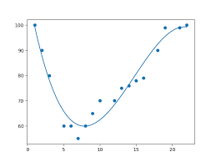

An example of Polynomial Regression.

In the model that I had implemented and using the data provided I was able to get an R2 score of **[0.99998551].**

I had used a cubic polynomial for my calculations.

**Logistic Regression: -**

Logistic regression is a process of modeling the probability of a discrete outcome given an input variable. It is used in classification problems. We can use algorithms like one verse all to apply it to multiclass variables. We had to device a program to classify alphabets using the EMNIST dataset. The model I ran gave an accuracy of **0.7046621621621622** on the test set.

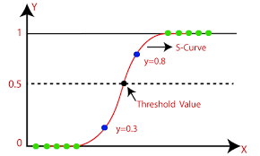

An example of Logistic Regression.

**KNN Algorithm: -**

KNN stands for K nearest neighbors. In this algorithm we find the K nearest neighbors of and then the data is given the same label as the majority of those data. The algorithm has a big disadvantage in its time of execution as for all data points in test set the system has to go through all the datapoints in the training set.

The model that I ran had an accuracy of **0.8428378378378378.**

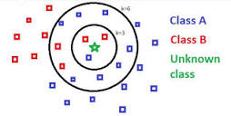

An example of KNN classification.

**K-clustering Algorithm: -**

K-means clustering aims to partition data into k clusters in a way that data points in the same cluster are similar and data points in the different clusters are farther apart. Similarity of two points is determined by the distance between them. Implementing K clustering and multiple problems mostly to with alphabets that look alike being clustered together or overlapping of clusters. Hence there was also varying accuracy of predictions. Ranging from **0.0** to **0.8675.**  The average accuracy was only - **0.3116447368421053**

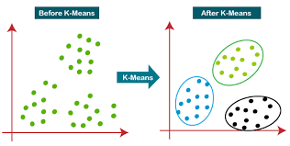

An example of Logistic Regression

**Neural Networks: -**

Neural networks are a series of algorithms that mimic the operations of an animal brain to recognize relationships between vast amounts of data. As such, they tend to resemble the connections of neurons and synapses found in the brain. They are used in a variety of applications in financial services, from forecasting and marketing research to fraud detection and risk assessment.

In our assignment we had to implement a 2-layer neural network on the EMNIST dataset to predict alphabets.

The model that I have implemented gave an accuracy of **0.8186599099099099** on the training dataset. It also gave an accuracy of **0.7814189189189189** on the test set.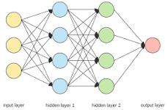

# Tech Stack-

* + Python
  + Libraries- NumPy, Pandas, Scikit-Learn and Matplotlib
  + VS Code
  + Jupyter Notebook

# About Me-

**Name**  :- Harsh Mishra

**Place**  :- Lucknow, Uttar Pradesh

**Email** :- [21JE0382@iitism.ac.in](mailto:21JE0382@iitism.ac.in), [harshmishralko31@gmail.com](mailto:harshmishralko31@gmail.com)

**GitHub** :- https://github.com/Harshlko31

**University**  :- Indian Institute of Technology (Indian School of Mines), Dhanbad

**Department** :- Civil Engineering